How to import an image in the program

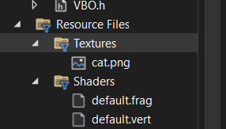

Create a Texture folder in the Resource Files folder and put the image there

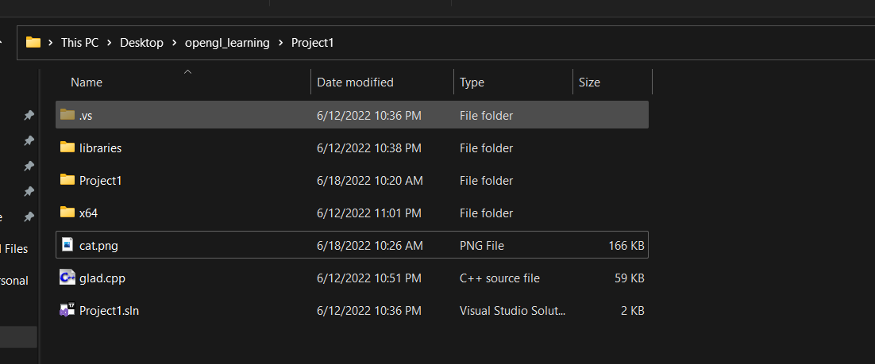

Also put the image inside the main project folder

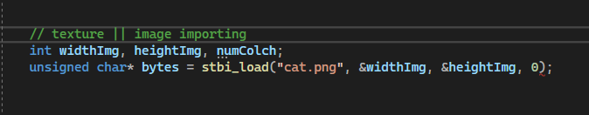

We create variables for image width, image height and number of color channel

We then store image inside the bytes array

Generating the texture object

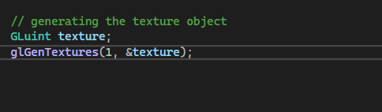

Like with every oopen gl object we first need to create the reference variable

Second we will create texture object via glGenTextures( ), first we will provide the number of textures we want to generate, second we provide the address of the reference variable

Now after creating texture object, we need to assign texture units

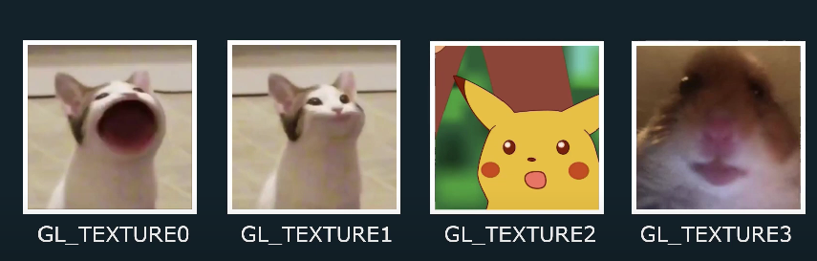

These are texture units

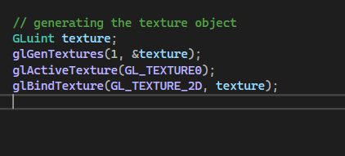

We setup our texture units

Now we need to set up either of these two texture setting



Choosing GL_NEAREST will keep all the pixels as it is

Choosing GL_LINEAR will make the required pixel, here image may appear blur

Now the another setting is how we want our pixel to be repeated

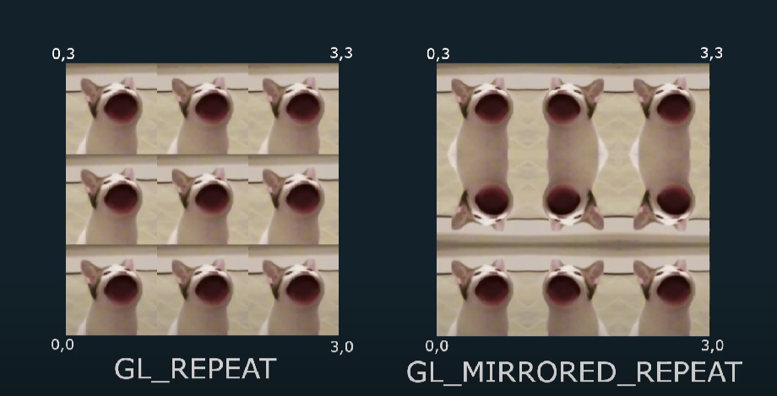

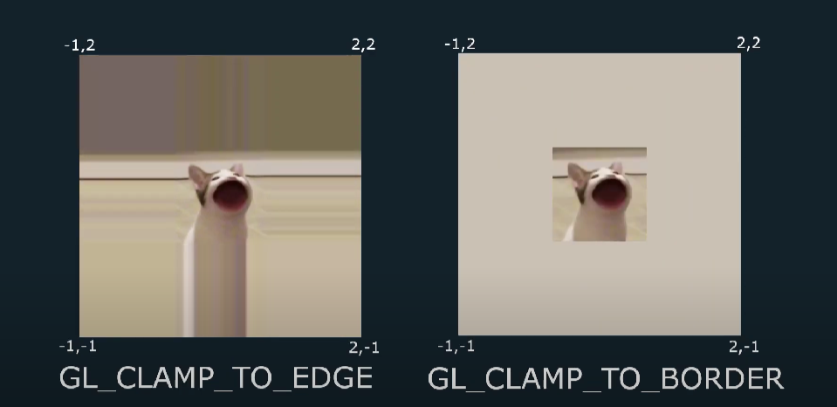

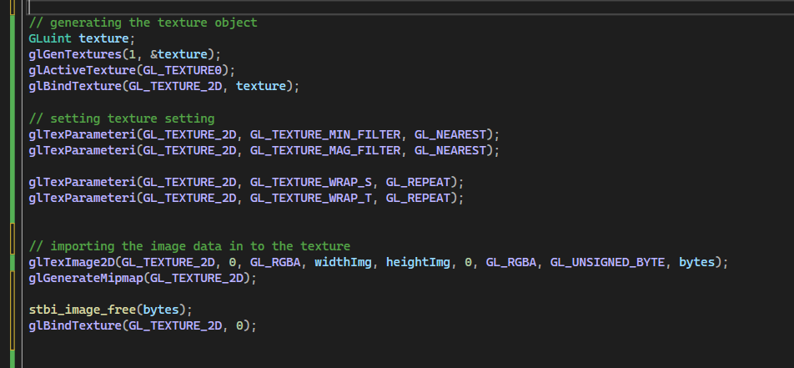

By doing all this we have the texture

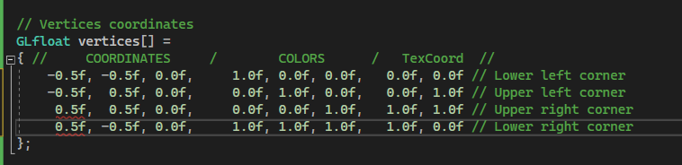

Here through TexCoord we specify how we want that texture to be mapped on the vertices

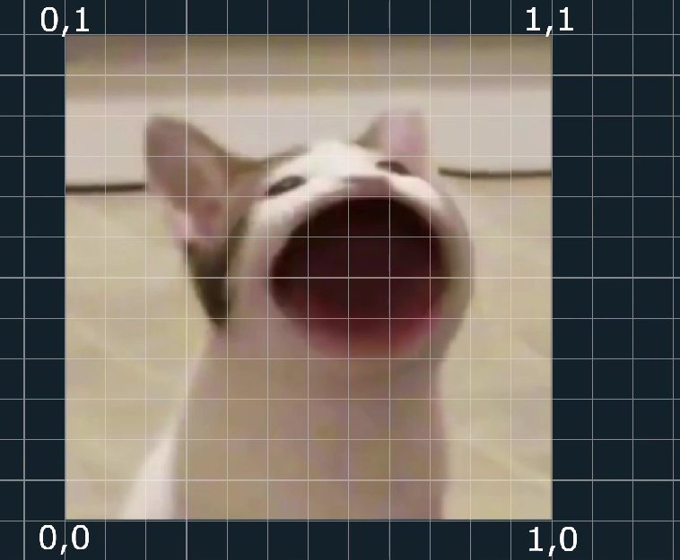

This is how the coordinate of texture goes, so we give the TexCoords in similar way

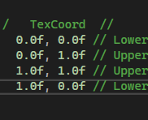

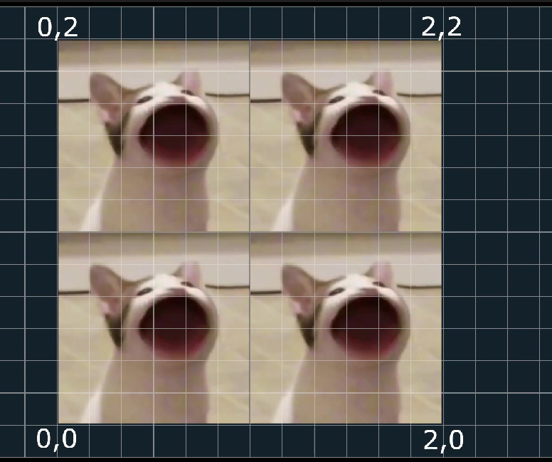

If we give the coordinate higher than one than the texture will be repeated